* **PROJECT NAME:** IRRIGATION MONITORING SYSTEM.
* **TEAM NAME:** TECHNIKA.
* **TEAM LEAD:** SHIVAM KUMAR**.**
* **MEMBER:** RIBHU SENGUPTA**.**
* **INSTITUTE NAME:** BENGAL COLLEGE OF ENGINEERING.
* **ADDRESS**: SHILPO KANAN ROAD, BIDHAN NAGAR,

DURGAPUR, DIST- BURDWAN,

STATE: WEST BENGAL.

* **SUB & THEME:** WATER AND IRRIGATION.

**A. Title: IRRIGATION MONITORING SYSTEM.**

This is a dynamic inherent representation of an IRRIGATION MONITORING SYSTEM which embarks to the facilitations set in order to mitigate the hard knocks of the Irrigation with galore obligations so needed.

**B. PROJECT DESCRIPTION:**

* **DEVELOPMENT CHALLENGE:**

India is an agriculture-based country. Hence why [**Agriculture**](https://www.omicsonline.org/searchresult.php?keyword=Agriculture)is the most important sector of [**Indian Economy**](https://www.omicsonline.org/searchresult.php?keyword=Indian%20Economy). Indian agriculture sector accounts for 18 per cent of India's gross domestic product (GDP) and provides [**employment**](https://www.omicsonline.org/searchresult.php?keyword=employment)to 50% of the countries [**workforce**](https://www.omicsonline.org/searchresult.php?keyword=workforce). Over 50% of population is dependent on agriculture. These structures the main [**source of income**](https://www.omicsonline.org/searchresult.php?keyword=source%20of%20income). These speculations curb the admissibility of the agriculture as an important act of intervention during the colonial period. India is uprising with a figure of global power which delivers a message of procurement towards the growing dependencies being the availability of the food as one among the major resources for its citizen and across the world. But with changing of decades and era, the hard knocks of the agrarian being scarcity of water has still limited the resource management skills. The agriculture has always witnessed deterioration compounding the immutable damages. For India, it has been the need of the hour i.e. an advance system equipped with the facilitation of **irrigation management** and **weather monitoring system**. While dealing with the irrigation system it will help to promote less dependencies towards rain-water. This system is capable enough to undermine hard knocks of varied climate, irregular and uncertain monsoon.

* **OPPORTUNITY IDENTIFIED - SOLUTION:**

This intimated model is hinge on a believed abstraction of an IRRIGATION MONITORING SYSTEM whose purpose is to provide a proposed objective of Irrigation with inherent desire of providing a primacy towards vegetation. This document encloses the dynamic representation of IRRIGATION MONITORING SYSTEM which is furnished with the facilities of fostering Moisture and Temperature of the soil which provides an assist to the components embarked within the system. The proposed system is a collateral compendium of IRRIGATION MONITORING SYSTEM with WEATHER MONITORING SYSTEM controlled by IOT.

The WEATHER MONITORING SYSTEM helps to produce the humidity and temperature around the system and records the data of the sunlight intensity. With the collateral of these, the acquired form of the data is then uploaded over the server.

The IRRIGATION MONITORING SYSTEM works in-order to the data received by the micro-controller. With the produced data of the weather system, the whole system is programmed so as to dispense water in order to meet the required temperature and humidity of the soil type. Moreover, for the measuring of the temperature and moisture of the soil type tends to be the primacy of the system.

* **INTELLECTUAL PROPERTY OF PROTOTYPE:**

The objective of this paper is creation of a microcontroller system for management of watering for precision agriculture. The system sends the watering data to a web server for processing, making it an internet of things project. So there is the junction of two expanding areas, the internet of things and precision agriculture. The electronic jargons are as mentioned below

* **ARDUINO MEGA.**
  + **ESP-8266 – Wi-Fi Module**
  + **SOIL MOISTURE SENSOR.**

It is used to monitor the Soil Moisture. The moisture content of soil is updated to the THINGSPEAK server. If the soil is dry then micro-controller automatically triggers relay to turn on water pump. The moisture content is dependent on the Soil type.

* **DS18B20 - Soil Temperature Sensor.**

It is used to monitor the Soil Temperature. The temperature of soil is updated to the THINGSPEAK server. If the temperature of soil is above the desired level, micro-controller triggers the relay to turn on water pump. The desired temperature level is dependent on the Soil type.

* **DHT-11 – (TEMPERATURE & HUMIDITY SENSOR).**
* **LDR.**
* **Rain Sensor**

It is to Monitors the rainfall and provides the idea of rainfall intensity and updates it over THINGSPEAK server.

* **LCD.**
* **RELAY - WATER PUMP.**
* **GSM MODULE.**
* **OUTPUT: LONG TERM BENEFITS.**

From this very collateral system of “IRRIGATION MONITORING SYSTEM” it will bring us the technology and the skills to the finger tips of the people. As we look forward to make use of this as a part of integrated resource management programme, the Agriculture science will get a prominent upward push. It not only will facilitate the technical sectors of our country rather will help as the employments generation scheme for today’s era.

With further more developments and basic updates, the system can be manor over. If this system is implemented with further more technologies, it will help to create a smart urban-agrarian management technique being a complete autonomous system.

Looking forward at the scope of skills, farmers dealing at the small scale could be directly benefited. By the mean of formulas and soil patterns, the machine is capable to be programmed as such to undermine the excess dependencies towards rainfall by a calculation of next to appropriate amount based on the calculations drawn. The electronic aspect with further more implementation of IOT has provided more vision to be developed and will help in due course of time to have a stringent monitoring over the working of the system.

* **IMPLEMENTATION:**

The proposed model is to be implemented as a corner stone at any piece of farm land and the system is to be turned on, being so developed to propose the weather as well as irrigation system, the system will firstly turn up the weather monitoring system and will acquire the weather data being humidity and the temperature of the environment. While turning up with the desired data, the system will turn to the next level of the irrigation monitoring system. In this course of system, the compendium of the sensors will look after the soil temperature and the temperature of the soil type. After matching up with the desired temperature and the moisture, the triggering of the relay-water pump will be functioned. This do facilitate the system with the duo sense of performance by easing up the hard knocks of the farmers as well as helps to plot up the data which could be required at any point of surveillance.

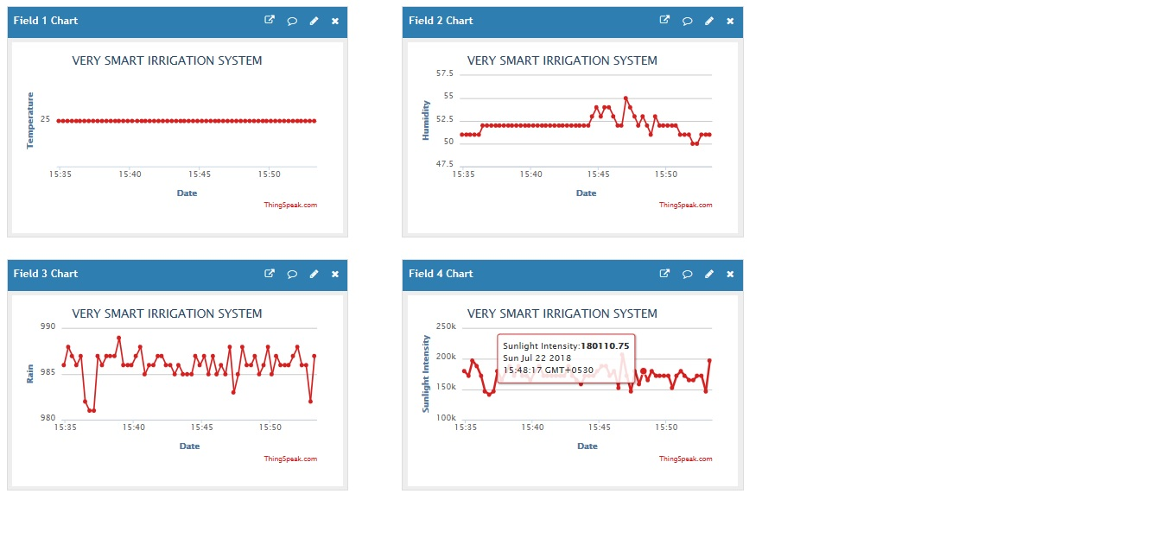 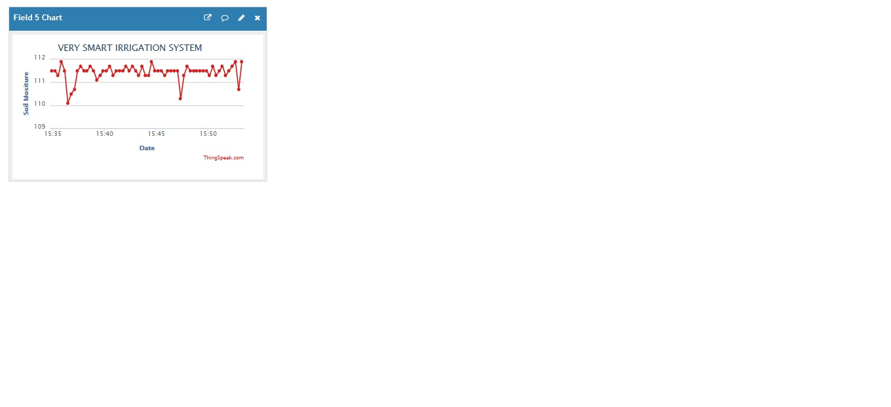

**ROLE OF EACH MEMBER:**

As per the representation of the aforesaid system. MR. Ribhu Sengupta has conveyed his work over the programming as well as over the development of the framework of the system and a spectator over the server interference.

MR. Shivam Kumar has put forward his effort over the development of the hardware modules involved in the system, allocation of the system configuration and drafting the report of this aforesaid project.

The team worked in a bid simultaneously for the checks and measures of the system and conveys the role of each member to be vital in this project.

**CONCLUSION:**

From the aforesaid informations provided, it helps to reach the speculations of the“IRRIGATION MONITORING SYSTEM” which embarks to the facilitisation of Artificial Intelligence and IOT to match up with the one of the major source of living, being agriculture, so abided to tackle the hardknocks of the farming sources.

**SIGNATURE:**

**_____________________ _____________________**

**(Team Leader) (Team Member 01)**

**DECLARATION: *I hereby declare that all the above information furnished herein by the team is true to the best of my knowledge. I understand and accept that our application for consent may be cancelled in case the above declaration is found to be false.***

***_____________________________***

***(*Name & signature of Mentor)**

**Date:**

**Place:**